***Project: Transport Management System***



***Group Members***

Abrar ul Hassan ---------------- 10970

Muhammad Faizan Khalid ----------------- 11359

Shan Gul ---------------- 12122

Muhammad Faizan -------1--------- 11491

Faizan ----------------- 11491

***Course Instructor***

Sir Ayyub Latif

Class ID ----------------- 111812

**Table of Contents**

INTRODUCTION 2

PURPOSE 2

SCOPE 2

PRODUCT PERSPECTIVE 3

PRODUCT FUNCTION 3

USER CHARACTERISTICS 3

INVENTORY MANAGER 3

BOOKING MANAGER 4

ACCOUNTING AND FINANCE MANAGER 4

GENERAL CONSTRAINTS 4

USER INTERFACE 4

SOFTWARE INTERFACE 4

FUNCTIONAL REQUIREMENTS 5

NON-FUNCTIONAL REQUIREMENTS………………………………………..5

FLOW OF EVENTS……………......………………………………………………

UML DIAGRAMS 6

USE CASE DIAGRAM 6

ACTIVITY DIAGRAM 7

CLASS DIAGRAM 9

SEQUENCE DIAGRAM 10

STATE DIAGRAM (BOOKING) 13

**INTRODUCTION**

Transport management system project is developed to automate transport operation like payment, booking order, delivery report, generating transactions receipt etc. in a transport office. Using this system user can computerize transport office work like billing, tracking payments, creating report etc. The main job of the transporter is to provide transport service to consigner and consignee.

# **PURPOSE**

A transportation management system (TMS) is a logistics platform that uses technology to help businesses plan, execute, and optimize the physical movement of goods, both incoming and outgoing, and making sure the shipment is compliant, proper documentation is available.

# **SCOPE**

# Transport Management System (TMS) is a software application designed to help manage transportation operations, such as planning and executing the movement of goods from one place to another. The scope of TMS is vast and encompasses a wide range of activities involved in the transportation of goods. A transportation management system (TMS) is a logistics platform that uses technology to help businesses plan, execute, and optimize the physical movement of goods, both incoming and outgoing, and making sure the shipment is compliant, proper documentation is available.

# PRODUCT PERSPECTIVE

Faster Process – To make sure a user gets his desire transport as early as possible; the Transport management system will provide a faster response to complete the process.

Minimize paperwork – As all the system is computerized, there is no need to fill any application form for renting purpose. So, the paperwork will be very less.

Centralized – All types of data and the activities related to the system will be kept in a single place so that it is easy to monitor the system and provide the customer the best service.

# PRODUCT FUNCTION

A Transport management system is a Window form platform that opens up new opportunities for your company. It manage your business, plan work, streamline routine operations, Book Transport, and receive detailed reports.

# USER CHARACTERISTICS

## **INVENTORY MANAGER**

Inventory manager will be able to add, update or delete transport models, Transport types, Expenses of Transport. Furthermore, inventory manager will be able to see reports

## **BOOKING MANAGER**

Booking manager will be able to create booking orders, book transport for customers, and update booking statuses.

## **ACCOUNTING AND FINANCE MANAGER**

ACF manager will be able to run monthly reports, deal with finances, and verify payments.

# GENERAL CONSTRAINTS

Some transport companies still use desktop applications for their transport management services and thus making it to be limited to so many important features that are not available, unlike the web-based application where there are so many features available.

# USER INTERFACE

The user interface will be simple and user friendly.

# SOFTWARE INTERFACE

WINDOW FORM.

# FUNCTIONAL REQUIREMENTS

Function requirements of our project are as follows:

1. Login Form

* A login form utilizes the credentials of a user, in order to authenticate their access. It generally consists of the typical username or email and password

1. Registration Form

* A registration form is a set of fields that a person fills out and sends to a business or individual to register for an event, program, membership, list, and so on.

1. Admin Metal Transport Information Make (Add, Update, Delete)

* An intelligent transportation system (ITS) is an advanced application which aims to provide innovative services relating to different modes of transport and enable users to be better informed and make safer, and 'smarter' use of transport networks. Admin can add, delete and update the information got from user

1. Admin Transport Expenses Make (Add, Update, Delete)

* Transportation expenses are a subset of travel expenses that refer specifically to the cost of business transportation by car, plane, train, etc. Expenses such as fuel, parking fees, lodging, meals, and telephone charges incurred by employees can be claimed as transportation expenses.

1. Admin Bill Report (Add, Update, Delete)

* Admin can create bill report according to customer book transport. Customer information should be name, address, amount etc.

1. View Transport Reports

* A View Transport Report feature within a Transport Management System (TMS) allows users to access and view these reports in a centralized location. It provides insights into transportation-related metrics and helps users identify trends, monitor costs, and optimize transportation operations.

1. Make Bookings (Add, Update)

* Enter the shipment details, including the origin and destination addresses, the type of shipment (e.g., parcel, pallet), weight, dimensions, and any special instructions or requirements. Select the carrier or carriers you want to use for the shipment. The TMS may have a list of carriers already set up, or you may need to enter the carrier details manually.

1. Verify Payments

* The payment verification process helps ensure that shipping charges are accurately recorded and that the customer has paid for the services provided. This information is important for financial reporting and managing cash flow within the logistics organization.

# NON-FUNCTIONAL REQUIREMENTS­

# Instant page loading

# Information will be secure and encrypted

# Responsiveness and usability will be accurate

# Software will be maintaining in every two weeks

# UML DIAGRAMS

## **USE CASE DIAGRAM**

## 



# **FLOW OF EVENTS**

# FLOW OF EVENTS OF VIEW RECORD PASSENGER

# Inventory Manager: View Record Passenger

# PRE-CONDITION

# Before going to this event assume that the manager has already login

# MAIN FLOW

# The flow begins when the user manager into his account and enters into the home page if all the credentials the manager can see all history of Passenger.

# ALTERNATIVE FLOW

# If manager has not was not be able to login then he can’t go ahead.

# FLOW OF EVENTS OF MANAGE VEHICAL

# Inventory Manager: Manage Vehicle

# PRE-CONDITION

# Before going to this event assume that the manager has already login

# MAIN FLOW

# The flow begins when the user manager into his account and enters into the

# DASH BOARD page if all the credentials the user wrote have been correctly filled.

# In this event manager will be able to.

# INSERT TRANSPORT

# UPDATE TRANSPORT

# DELETE TRANSPORT

# ALTERNATIVE FLOW

# If manager has not was not be able to login then he can’t go ahead.

# FLOW OF EVENTS OF CHECK TRANPSORT VEHICAL

# Booking Passenger: Check Transport Vehicle

# PRE-CONDITION

# Before going to this event assume that the Passenger has already login

# MAIN FLOW

# The flow begins when the Passenger into his account and enters into the

# DASH BOARD page if all the credentials the user wrote have been correctly filled.

# ALTERNATIVE FLOW

# If Passenger has not was not be able to login then he can’t go ahead.

# FLOW OF EVENTS OF CHECK BOOKING STATUS

# Booking Passenger: Check Book Status

# PRE-CONDITION

# Before going to this event assume that the Booking Passenger has already login

# MAIN FLOW

# The flow begins when the Booking Passenger into his account and enters into the

# DASH BOARD page if all the credentials the user wrote have been correctly filled.

# Passenger check booked seats and History of his activity.

# ALTERNATIVE FLOW

# If Booking Passenger has not was not be able to login then he can’t go ahead.

# FLOW OF EVENTS OF VIEW TRANSPORT VEHICLE

# Booking Passenger: View Transport Vehicle

# Precondition

# Before going to this event assume that the Passenger has already login

# MAIN FLOW

# The flow begins when the booking Passenger into his account and enters into the home page if all the credentials the user wrote have been correctly filled.

# In this event Passenger will be able to.

# Passenger Can check the Available seats

# Get information about seat books

# Vehicle Type Check

# ALTERNATIVE FLOW

# If Passenger has not was not be able to login then he can’t go ahead

# FLOW OF EVENTS OF MANAGE BOOKING

# Booking Passenger: Manage Booking

# PRE-CONDITION

# Before going to this event assume that the Booking Passenger has already login

# MAIN FLOW

# The flow begins when the user Passenger into his account and enters into the

# DASH BOARD page if all the credentials the user wrote have been correctly filled.

# In this event manager will be able to.

# INSERT Vehicle Detail

# UPDATE Vehicle Detail

# DELETE Vehicle Detail

# ALTERNATIVE FLOW

# If Booking Passenger has not was not be able to login then he can’t go ahead.

# FLOW OF EVENTS OF MANAGE TRANSPORT FINANACE

# Account Manager: Manage Transport Finance

# PRE-CONDITION

# Before going to this event assume that the Finance Manger has already login

# MAIN FLOW

# The flow begins when the finance transport manager into his account and enters into the DASH BOARD page if all the credentials the user wrote have been correctly filled.

# In this event manager will be able to.

# INSERT TRANSATION OF VEHICLE

# UPDATE TRANSATION OF VEHICLE

# DELETE TRANSATION OF VEHICLE

# ALTERNATIVE FLOW

# If Finance Manager has not was not be able to login then he can’t go ahead.

REALIZATION OF USE CASE DIAGRAM

Realization Use Case of View Record Passenger

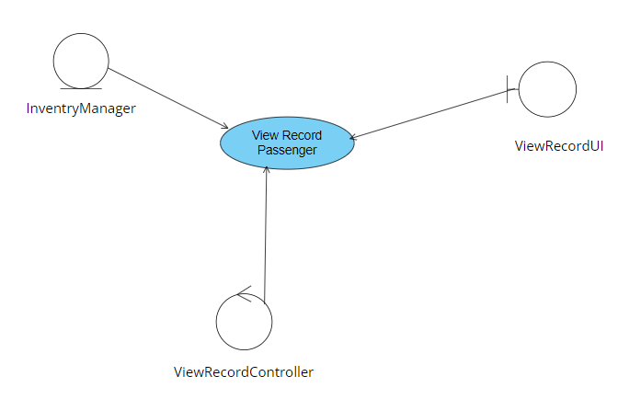

Realization Use Case of View Record Passenger

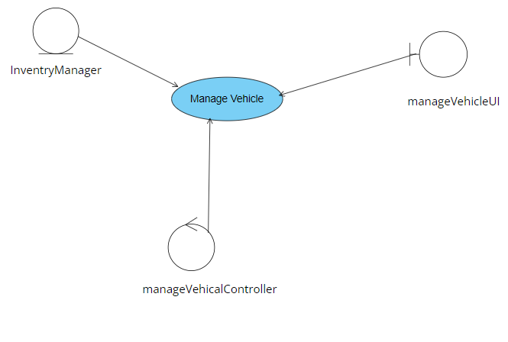

Realization Use Case of Check Transport Vehicle

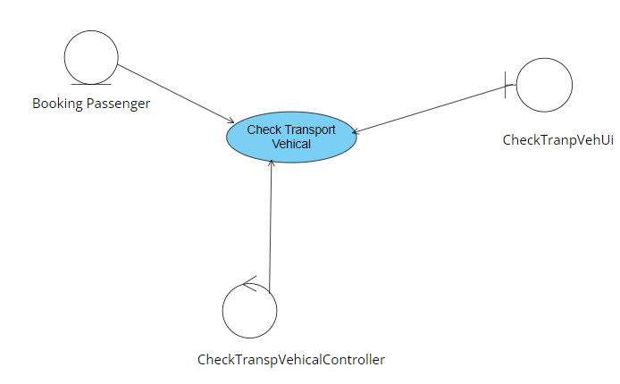

Realization Use Case of Check Transport Status

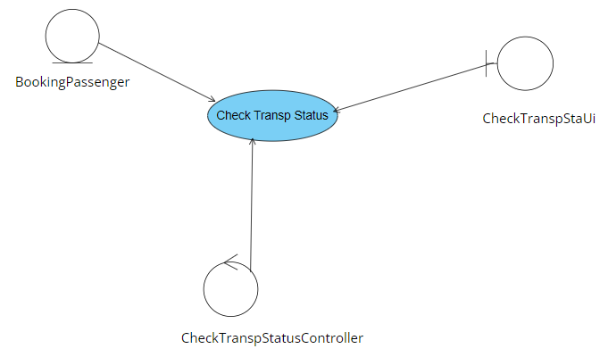

Realization Use Case of view transport Vehcle

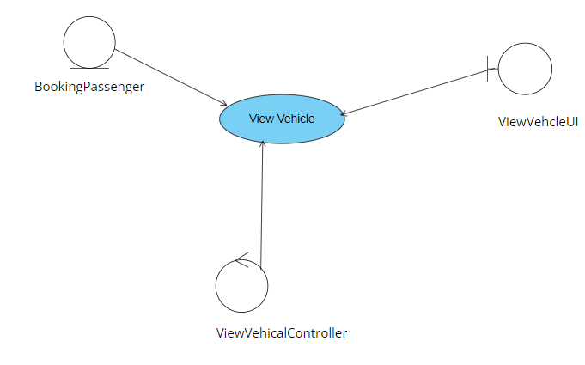

Realization Use Case of Manage Booking

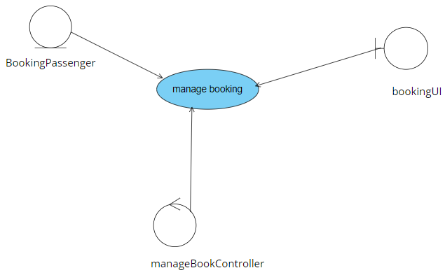

Realization Use Case of Check manage Transport Finance

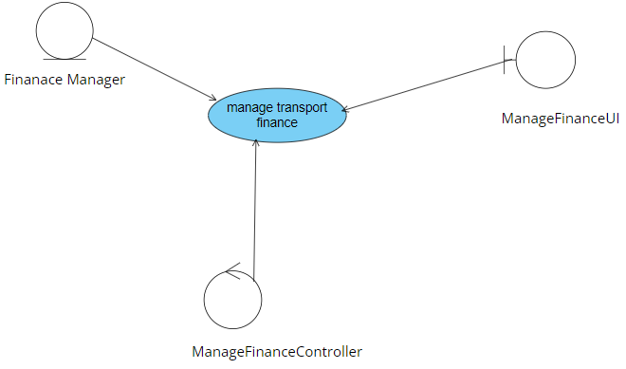

## **ACTIVITY DIAGRAM**

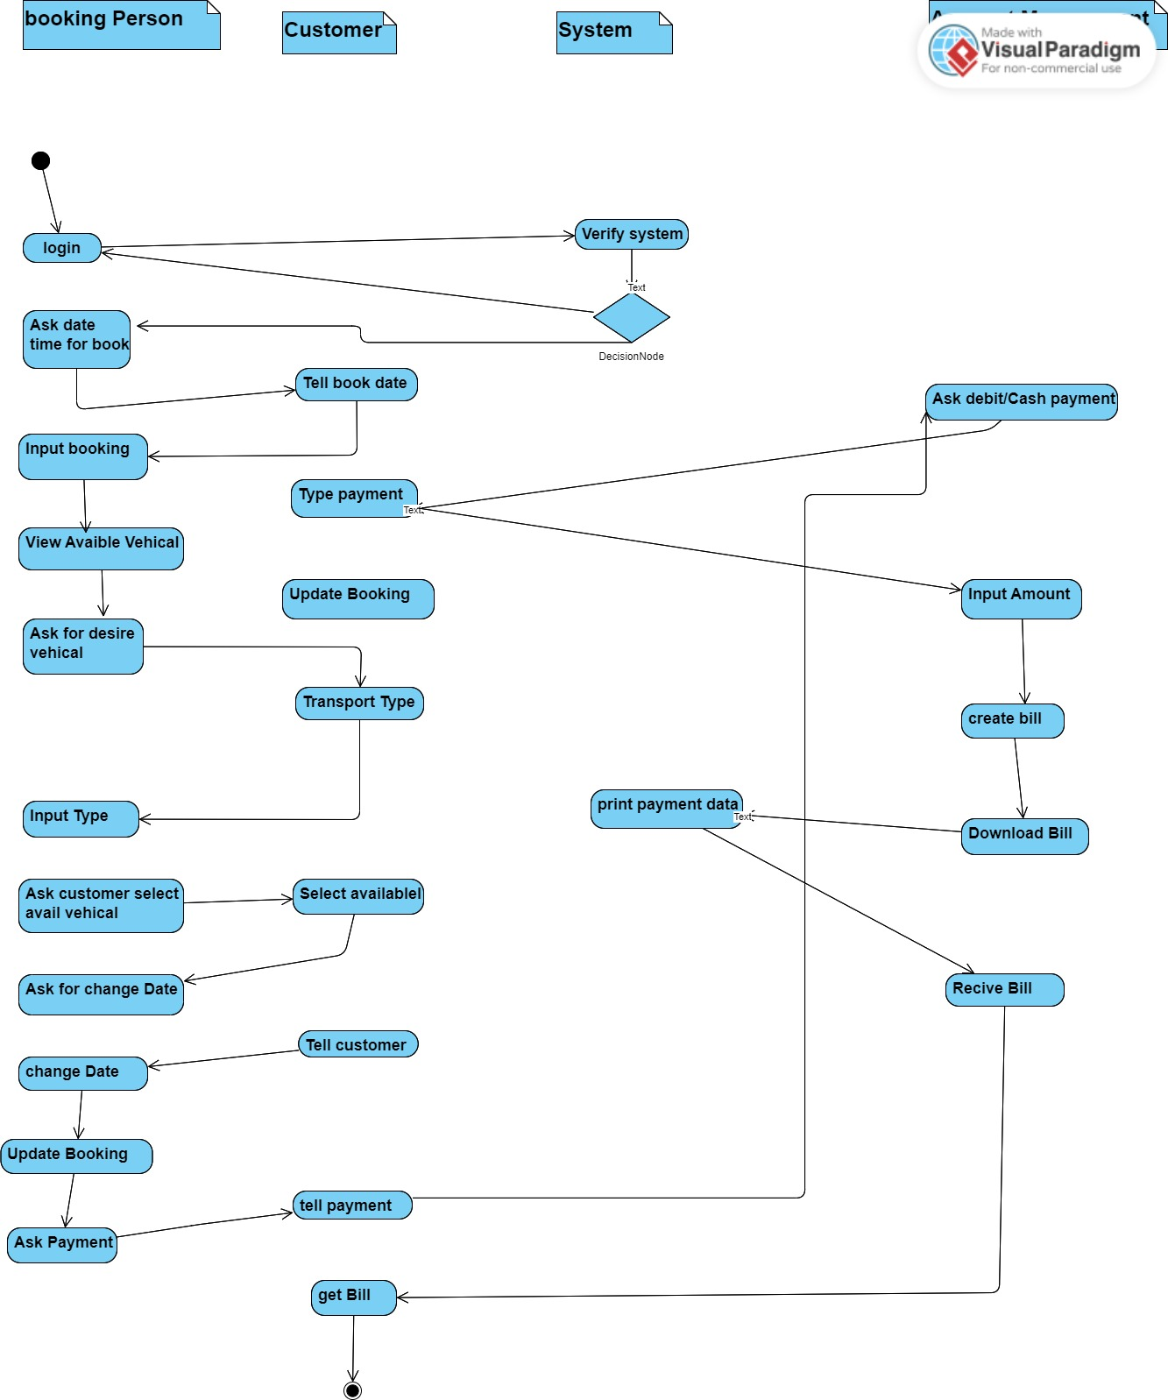

**SEQUENCE DIAGRAM**

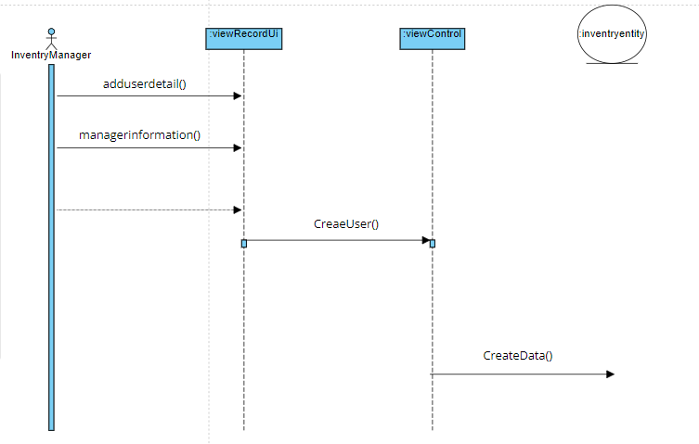

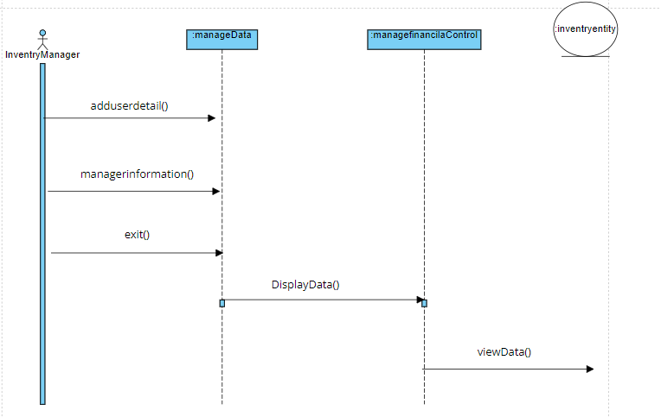

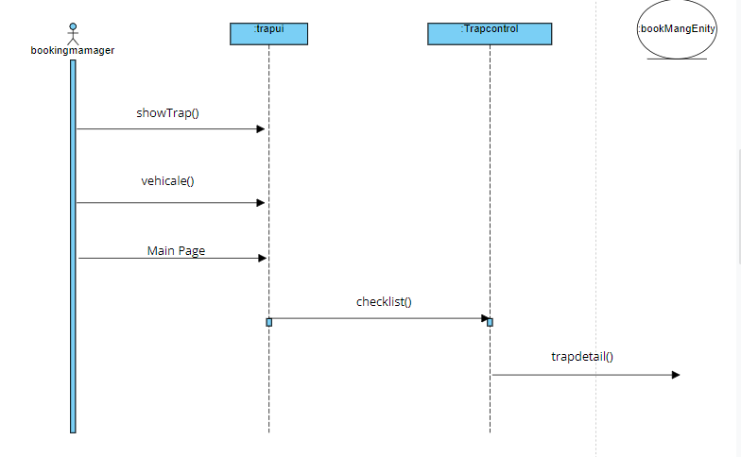

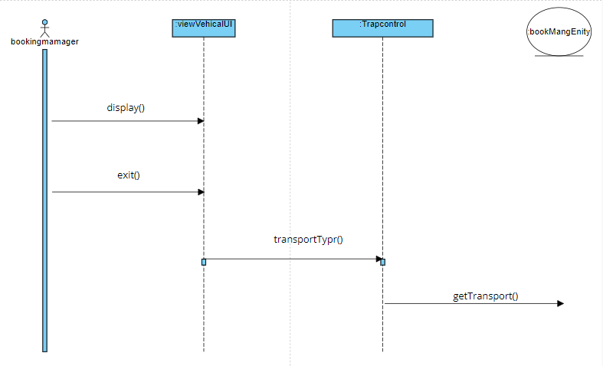

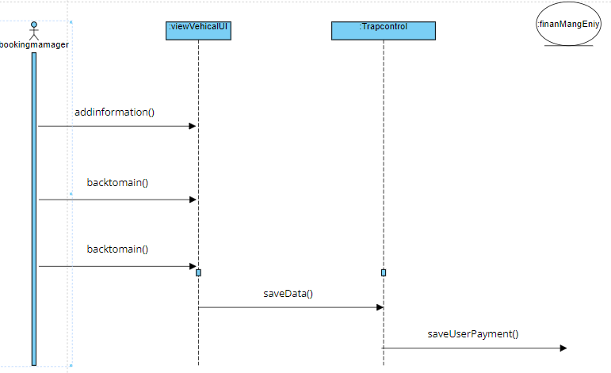

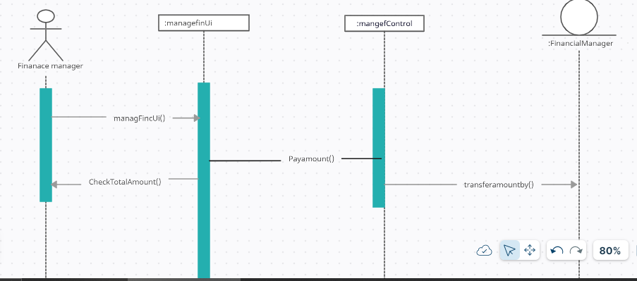

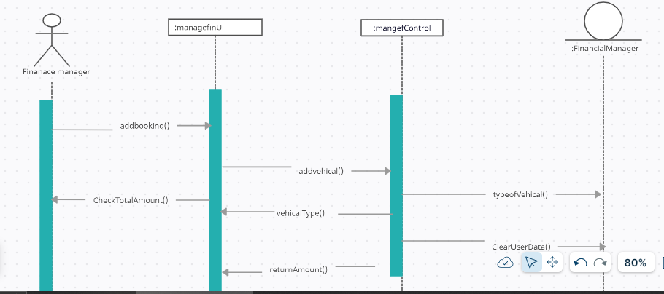

## **CLASS DIAGRAM**

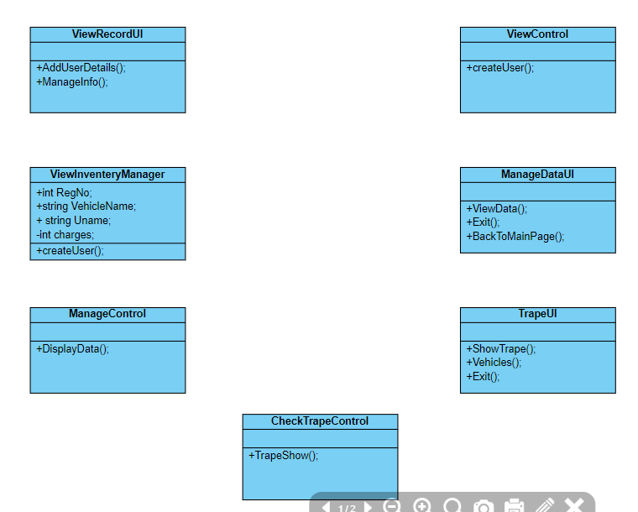

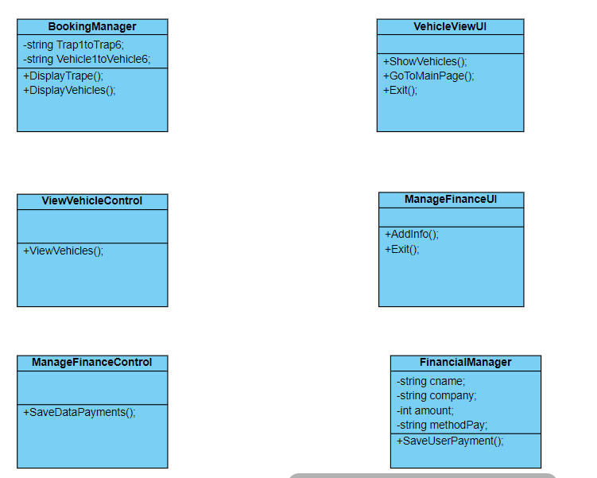

**GUI PROJECT**

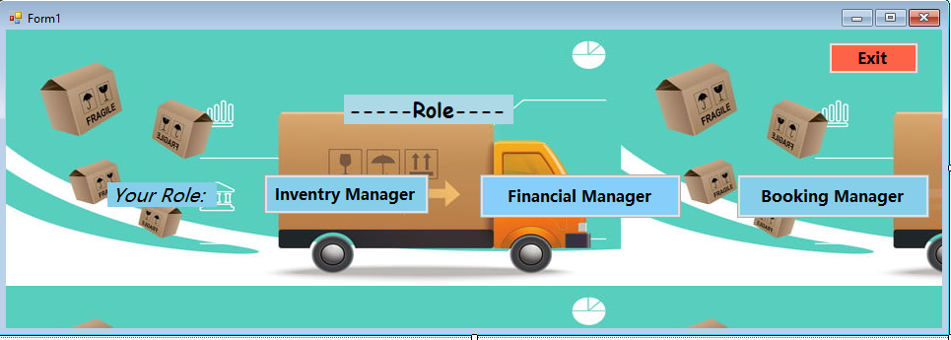

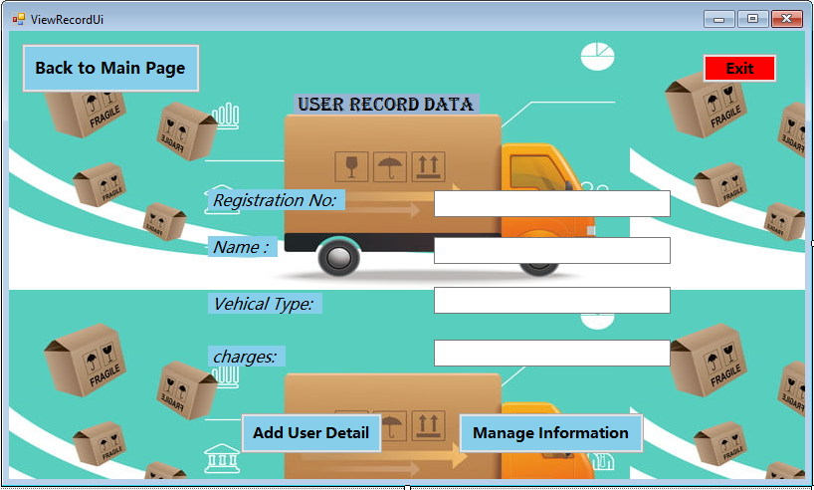

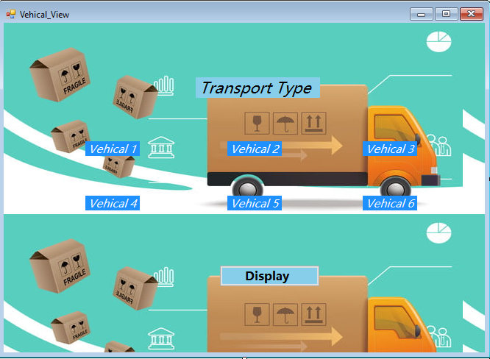

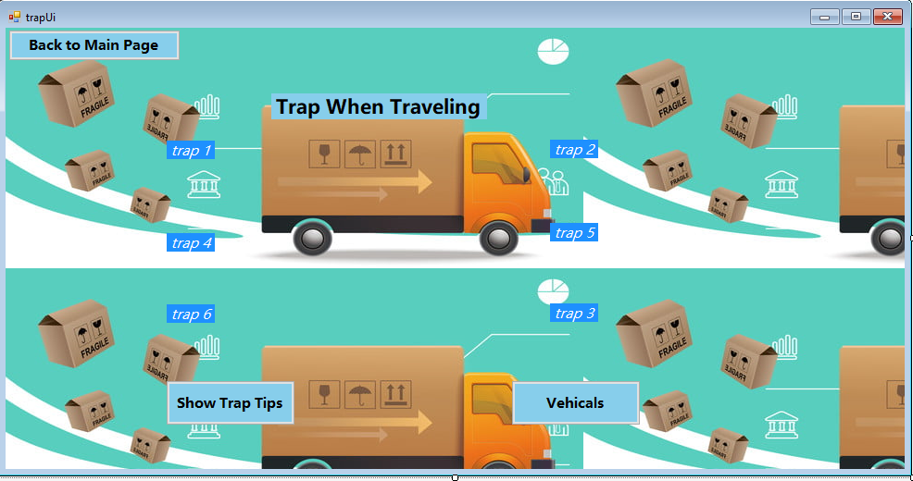

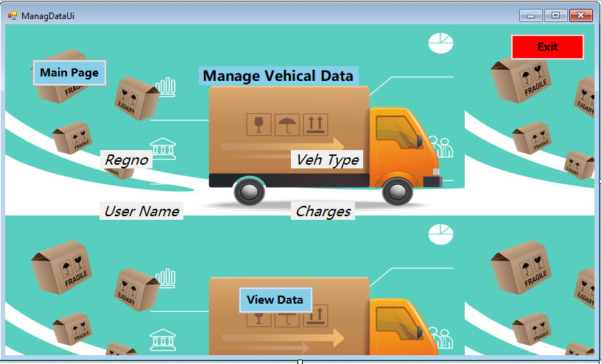

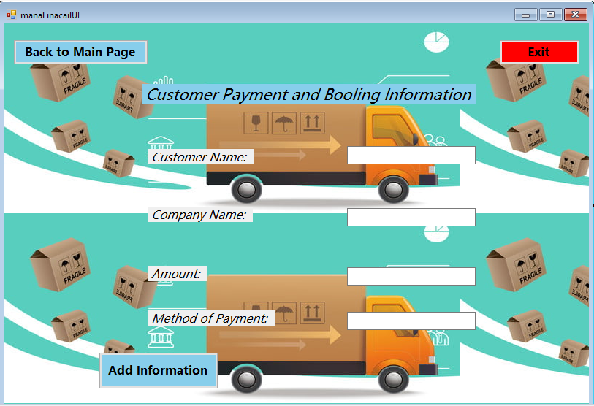

**State Chart Diagram**

**Object -- > View Record**

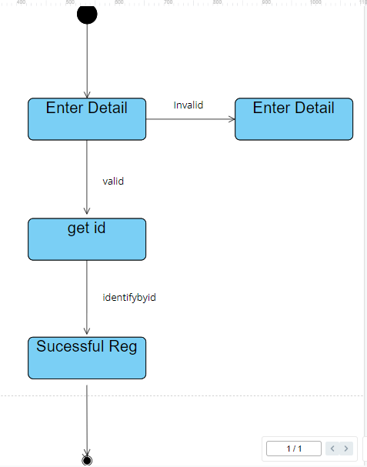

**OBJECT 🡪 manage Infor**

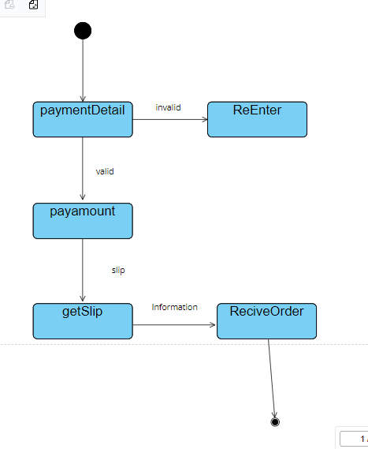

**Entity Relationship Diagram:**

